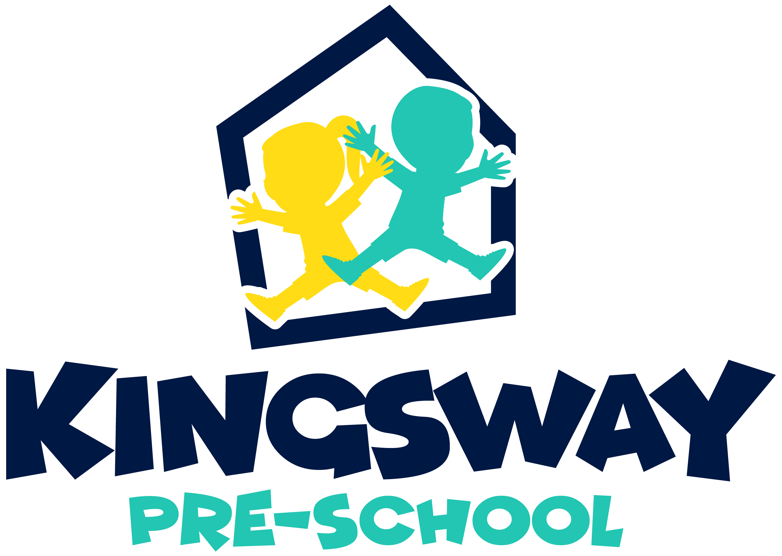

CHILD’S FULL NAME DATE OF BIRTH

HOME ADDRESS

POST CODE GENDER FUNDING CODE

NAME OF PARENTS/LEGAL GUARDIANS

PARENT N I NUMBER (for funding) PARENT D.O.B

E-MAIL
(By providing this I/we actively consent to Kingsway Preschool contacting us with information relevant to the Preschool and for parent/carer activation of Tapestry learning journal)

HOME TELEPHONE MOBILE

Alternative phone number/s through which Parent/Carer may be contacted (e.g. work)

Emergency contact name Emergency contact number

If your child is cared for on a regular basis by anyone else, please give details below.

Name Phone Number

Address

Child’s Doctor’s Name Dr’s Phone Number

Address

Childs Dentist Name and address

Childs Health Visitor Name
Has your child been immunized? (inc MMR) YES / NO
Please list

Has your child any allergies, medical conditions or dietary requirements? YES / NO

Please list

Has your child any special needs? YES / NO

If so what are they

What is the main language spoken at home?

What school do you anticipate your child will be attending?

AS PART OF YOUR CHILDS LEARNING JOURNEY WE CARRY OUT OBSERVATIONS AND SUMMARIES OF LEARNING AND DEVELOPMENT. THIS INFORMATION WILL BE PASSED ONTO THEIR RELEVANT SCHOOL WHEN THEY LEAVE.

As part of their online learning journal, we take photographs and video clips of the children at play.
Is your permission given for these to be taken for the online learning journals? YES / NO

Is your permission given for your child to participate on trips out with us during the session? YES / NO
(To the local shops/library/field trips/litter-picking etc)

Would you like us to contact you prior to taking your child on trip out of the setting? YES / NO
(see examples above)

AS A CHARITY PARENT RUN COMMITTEE AND AS PART OF OUR PRE-SCHOOL POLICY WE ASK THAT A PARENT ATTEND THE ANNUAL GENERAL MEETING FOR VOTING PURPOSES.

I / we will attend the AGM meeting YES / NO

If any information contained on this form changes such as my address,
telephone number, email, I understand I must inform the pre-school immediately YES / NO

If my child no longer requires a place, I will inform the pre-school immediately. YES / NO
I understand I am required to give four weeks’ notice if my child leaves
(Fees will still be payable during the notice period)

I/we accept and understand that fees are due half termly in advance YES / NO

I/we understand and accept that supply fees are payable each half term. YES / NO (This applies to children in receipt of funded places for consumables)

I/we understand that availability of 2, 3 & 4 year old places may YES / NO
involve my Childs name being added to a waiting list
I/we accept places cannot be held open for us by the pre-school

I/we have paid the current enrolment fee YES / NO
(This fee will cover administration, resources and any visits prior to starting pre-school.)

I/we have read and understood the contents of this registration form and I am
aware a full set of Kingsway policies can be seen at www.kingswaypreschool.co.uk YES / NO

FUNDED PLACES – Please see our website www.kingswaypreschool.co.uk for information on funding.
Once your child is offered a place and you accept it, on admission further personal information and family details may be required for our records. If you find that you no longer need the place, please inform us as soon as possible. Should you decide you no longer need the place we will not retain the details on this application form (see our Privacy Notice).

PARENT/CARER SIGNATURE…………………………………… DATE ...............................................

Once your child joins us their Birth Certificate is required and a copy will be made on their Tapestry file.

Preferred initial sessions (these cannot be guaranteed)
Mon am | Tues am | Wed am | Thurs am | Fri am
Mon pm | Tues pm | Wed pm | Thurs pm | Fri pm

FOR KINGSWAY STAFF TO COMPLETE ONLY

START DATE BIRTH CERTIFICATE NUMBER

2 YR FUNDING CODE 30 HR FUNDING CODE

